Minor ES – Connectivity - Hello World

Authors: Bas Woudstra, Rafał Grasman

# Assignment

Two Xbee modules must communicate with each other.

# Setup

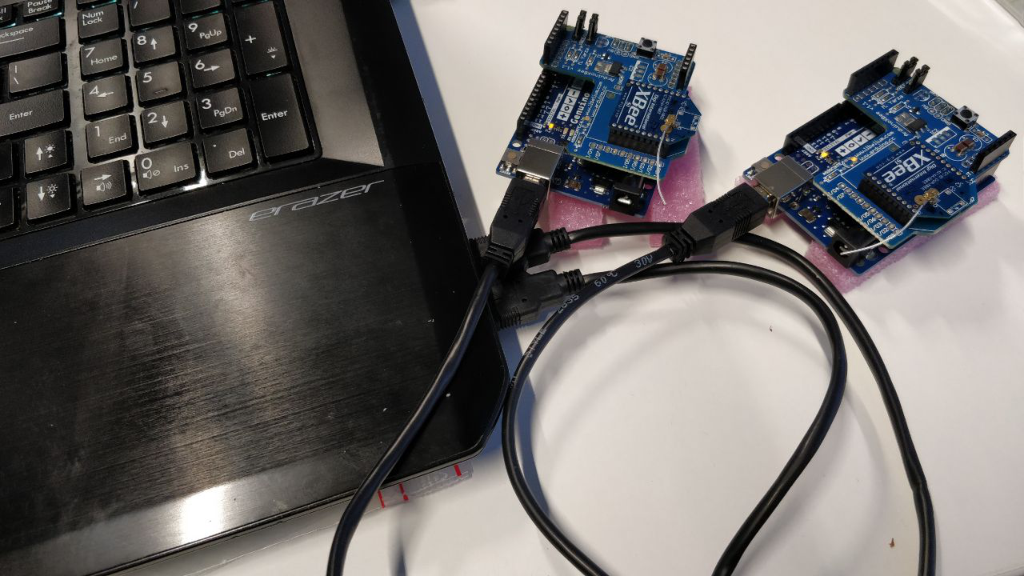

# Code

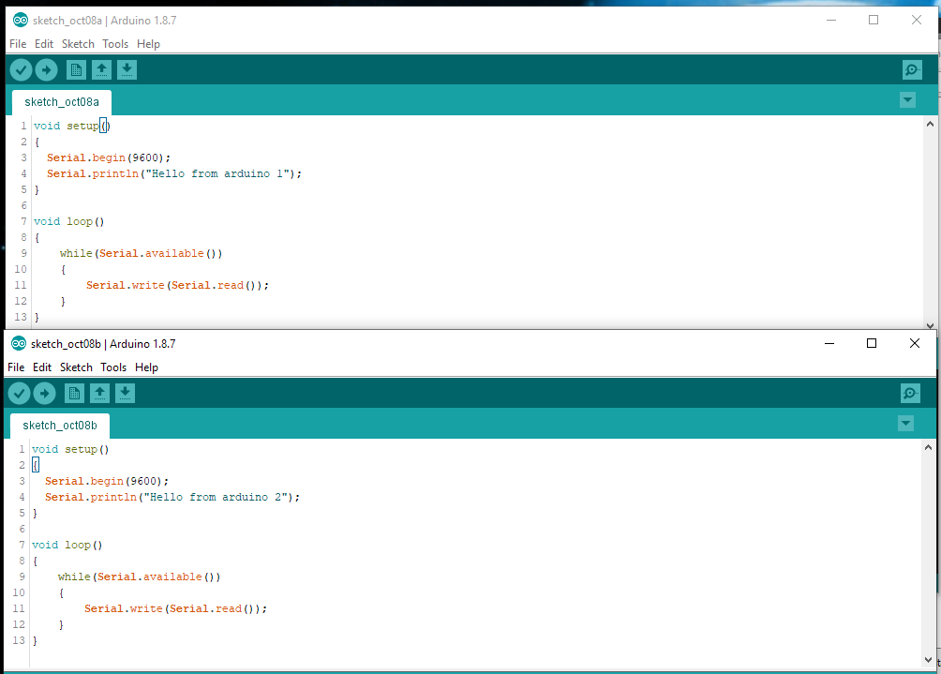

# Results

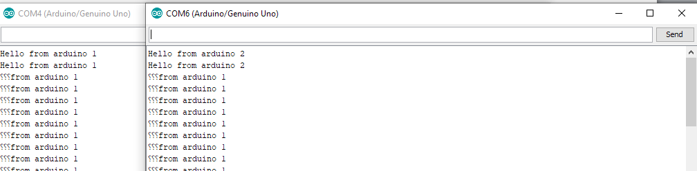

We can see the arduino1 first starts sending bytes so the Arduino 2 is in constant receiving state (and repeating the text / broadcasting). Some first bytes got shaved off due to an unknown reason. Further attempts to rectify the issue did not yield positive results.